Console App Demo - Read Me

Step 1 :

This solution is build using .NET Core 1.x. Hence make sure the laptop has 1.x Installed before running the project.

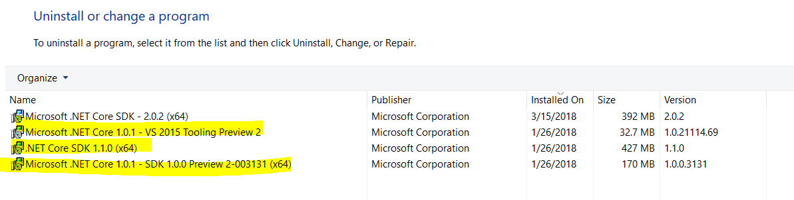

Step 2: After opening the **RecordInfo** solution file, please build in below order

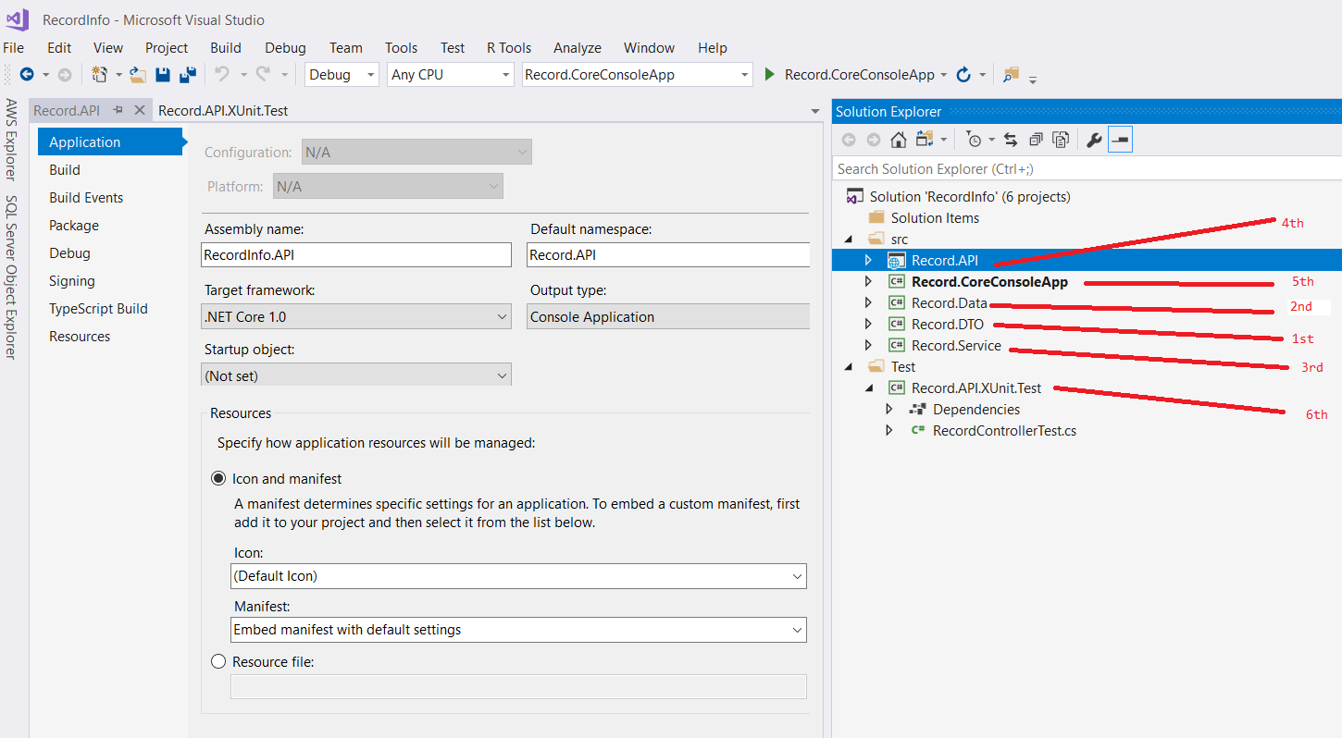

Step 3: As per the assignment , if you want to see the console application output you have to mark “Record.CoreConsoleApp” project as startup project.

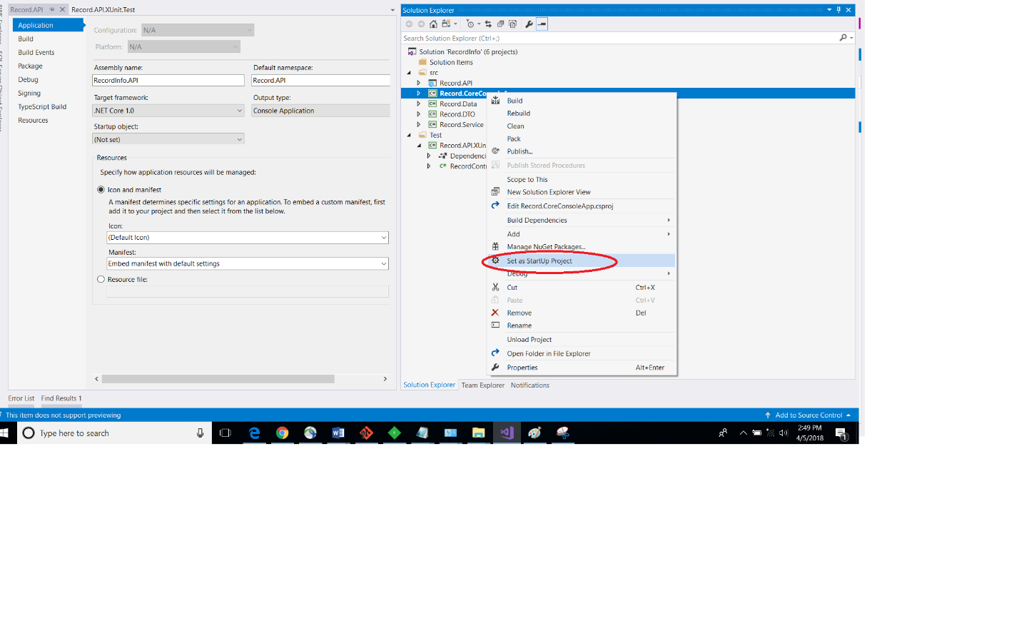

Step 4 : Once you click on Run after above step you would be asked to select options . For you convenience default data is already loaded.

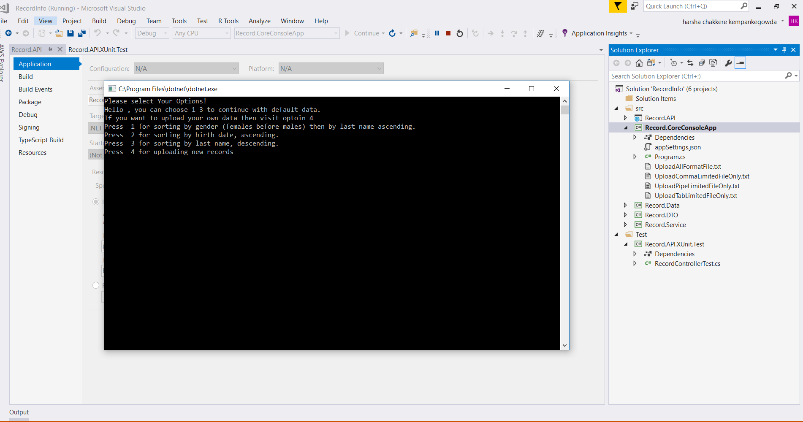

Step 5 : If you choose to upload you own data then please open the Project root Location for console app “**Record.CoreConsoleApp**” & locate files following highlighted files for modification.

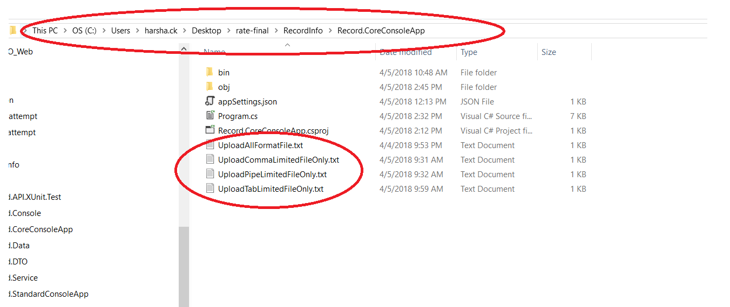

Step 6 : In below image a I Choose upload option with TAB limited records . You can see the default sorting behavior too ..

